**DAILY ONLINE ACTIVITIES SUMMARY**

|  |  |  |  |  |  |  |  |  |
| --- | --- | --- | --- | --- | --- | --- | --- | --- |
| **Date:** | **19/05/202** | | | | | **Name:** | **Anjali Manohar Prabhu** | |
| **Sem & Sec** | **4th Sem Section-‘A’** | | | | | **USN:** | **4AL18CS007** | |
| **Online Test Summary** | | | | | | | | |
| **Subject** | | **DESIGN AND ANALYSIS OF ALGORITHM (18CS42)** | | | | | | |
| **Max. Marks** | | **30** | | **Score** | | | **02** | |
| **Certification Course Summary** | | | | | | | | |
| **Course** | **PYTHON IN MACHINE LEARNING** | | | | | | | |
| **Certificate Provider** | | | 1. **Great Learning Academy** | | **Duration** | | | **1.45min** |
| **Coding Challenges** | | | | | | | | |
| **Problem Statement:** 1. Printing the odd and even numbers using thread | | | | | | | | |
| **Status: Completed** | | | | | | | | |
| **Uploaded the report in Github** | | | | | **Yes** | | | |
| **If yes Repository name** | | | | | [**https://github.com/vinisharen/lockdown-coding**](https://github.com/vinisharen/lockdown-coding) | | | |
| **Uploaded the report in slack** | | | | | **Yes** | | | |

Online Test Details: Online test for DAA (18CS42) was scheduled from 9:30 to 10:00 AM and the syllabus for the exam was 1st module. There were 25 questions (MCQ) and the time allotted for the test was 30 min

Certification Course Details: Anaconda Individual Edition contains [conda](https://conda.io/en/latest/) and [Anaconda Navigator](https://docs.anaconda.com/anaconda/navigator/), as well as Python and hundreds of scientific [packages](https://docs.anaconda.com/anaconda/packages/). When you installed Anaconda, you installed all these too.

Conda works on your command line interface such as Anaconda Prompt on Windows and terminal on macOS and Linux.

Navigator is a desktop graphical user interface that allows you to launch applications and easily manage conda packages, environments, and channels without using command-line commands.

Snapshot: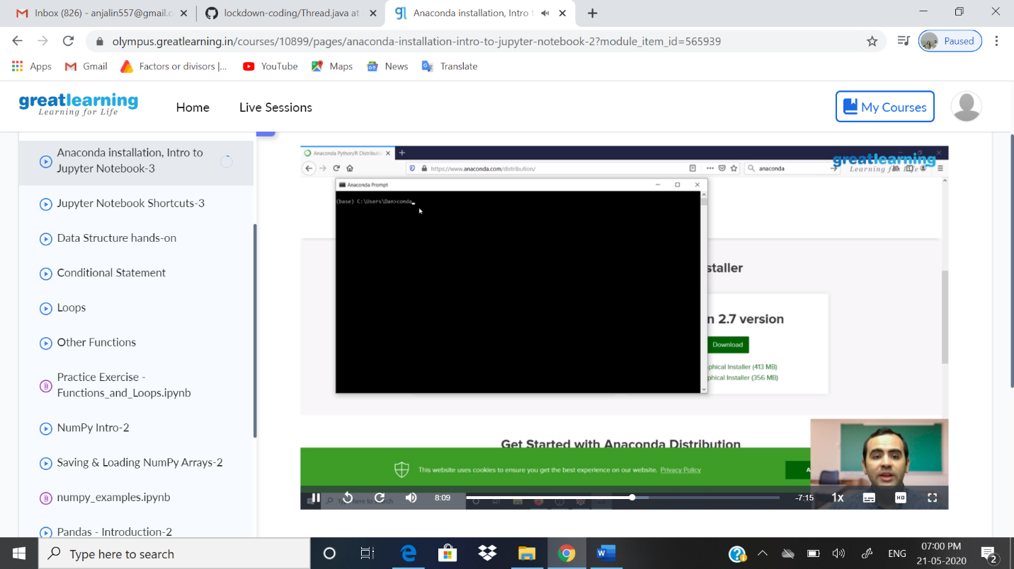

Coding Challenges Details: Problem statements: .

1. Printing the odd and even numbers using thread

Solution: Uploaded in github

Snapshot: